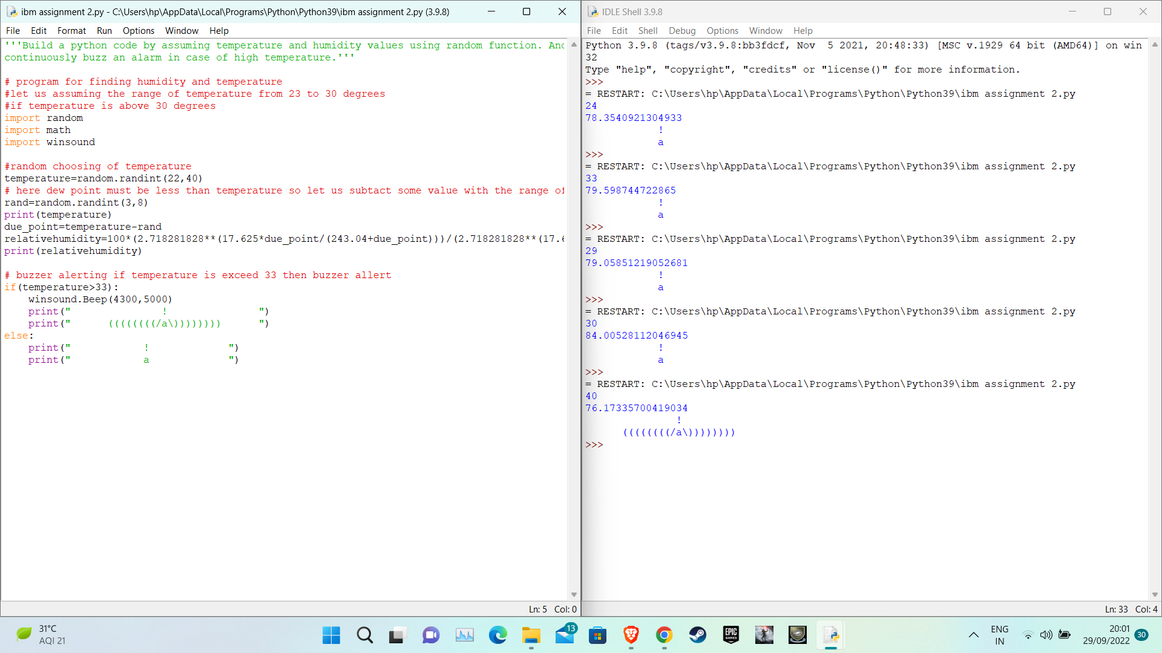

https://drive.google.com/file/d/1qqcGZCNwukDAx2QOR7y5avxGYWEnfp3S/view?usp=drivesdk